PROJECT DOCUMENTATION

Members;
- Jakes Sandei BIT/2024/73669
- James Chege BIT/2024/56466
- Justin Kimai BIT/2024/49628
- Ian Kiptoo BIT/2024/54040
- Faith Mujisa BIT/2024/56208
- Wambugu Ian BIT/2024/55296
- John Waweru BIT/2024/55469
- Mark Mwangi BIT/2024/51549
- Nathan Kariuki BIT/2022/51436

1. Project Title
Design and Drafting of Electrical, Water Supply, and WiFi Network Layout for a 14-Storey Commercial Building Using AutoCAD

2. Introduction
This project involves the design and drafting of building service systems for a 14-storey commercial building using AutoCAD. The focus is on three major systems:
- Electrical power distribution
- Water supply and plumbing system
- Wireless internet (WiFi) network infrastructure
The drawings include floor plans, and schematic layouts for proper installation and maintenance.

3. Project Objectives

3.1 General Objective
To design a complete building services layout for a 14-storey building using AutoCAD.

3.2 Specific Objectives
- To create architectural floor plans in AutoCAD.
- To design electrical distribution layouts for all floors.
- To design water supply and drainage systems.
- To design wifi network coverage and cable routing.

4. Project Scope
The project covers:
- Ground floor to 14th floor layouts
- Electrical wiring system (lighting and power outlets)
- Water supply system (cold water)
- Drainage system
- WiFi access points
- Vertical service shafts

5. Software and Tools Used
- AutoCAD – For drafting and layout design
- Computer system (Windows OS)

6. Building Description
- Type: Commercial/Office Building
- Number of Floors: 14
- Each floor includes:
  - Office spaces
  - Washrooms
  - Electrical room
  - Staircase and lift

7. Electrical System Design

7.1 System Overview
The building electrical system is supplied from the main utility power grid and distributed through:
- Vertical riser cables

7.2 Electrical Components
- Lighting fixtures
- Switches
- Socket outlets
- Distribution boards

8. Water Supply System Design

8.1 Water supply

A plumbing plan was intergrated into the floor plan from pipping to every floor.

9. WiFi Network Design

9.1 System Overview
The building WiFi network provides internet connectivity to all floors through structured cabling.

9.2 Network Components
- Internet service provider (ISP) connection
- Main server room (Ground floor)
- Ethernet cables
- Wireless Access Points (APs)

9.3 Distribution Method
- Backbone fiber cable runs vertically through the shaft.
- Network switches are installed on each floor.
- Access points are evenly distributed for full signal coverage.

9.4 Drawings Produced
- WiFi access point layout
- Data cable routing plan
- Network riser diagram

10. AutoCAD Drawing Structure

10.1 Layers Used
Layer Name | Purpose
WALLS | Architectural walls
ELECT-LIGHT | Lighting wiring
ELECT-POWER | Power sockets
WATER-SUPPLY | Water pipes
DRAINAGE | Waste pipes
WIFI-DATA | Data cables
TEXT | Annotations

10.2 Drawing Scales
- Floor Plans: 1:100
- Riser Diagrams: 1:200
- Details: 1:50

11. Methodology
- Created base architectural plan in AutoCAD.
- Designed electrical layout floor by floor.
- Designed plumbing system and vertical risers.
- Positioned WiFi access points for full coverage.
- Organized drawings using layers.
- Added dimensions, annotations, and title blocks.
- Generated final printable layouts.

12. Challenges Encountered
- Coordinating service shafts for all systems.
- Avoiding clash between water pipes and electrical conduits.
- Ensuring even WiFi coverage on large floor areas.
- Managing layer organization in AutoCAD.

Here is a the Final floor Plan with electrical wiring, plumbing included. 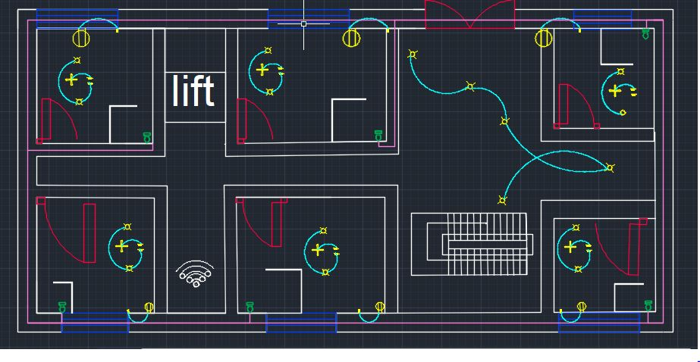

13. Conclusion
The project successfully demonstrates the use of AutoCAD in designing integrated building service systems for a 14-storey building. The electrical, plumbing, and WiFi systems were carefully planned and drafted to ensure efficiency, safety, and functionality.
This project enhances skills in CAD drafting, building services planning, and system coordination.

